CORE TEST CASES

6.5.1 “Valid Login” Test Case
Field | Details
Test Case ID | TC-001
Use Case Name | Log In
Summary Description | The user needs to log-in to use the application
Pre-Condition | The user should have Internet availability
Test Procedure | 1. User enters valid username/email 2. User enters valid password 3. User presses “Login” button
Test Data | 1. Enter Normal data and press “Login” button • Username: “admin@test.com” • Password: “Admin@123”
Expected Result | 1) Show success message 2) Redirect to Dashboard
Actual Result | 1) Show success message 2) Redirected to Dashboard
Status | Pass

6.5.2 “Invalid Login” Test Case
Field | Details
Test Case ID | TC-002
Use Case Name | Invalid Log In
Summary Description | The user enters incorrect credentials
Pre-Condition | The user should have Internet availability
Test Procedure | 1. User enters invalid username/password 2. User presses “Login” button
Test Data | 1. Enter Abnormal data • Username: “wrong@test.com” • Password: “12345” 2. Enter Extreme data • Username: “ ” • Password: “ ”
Expected Result | 1) Show error message (“Invalid credentials”) 2) Show error message (“Please enter required fields”)
Actual Result | 1) Error message displayed 2) Validation message shown
Status | Pass

Screenshots
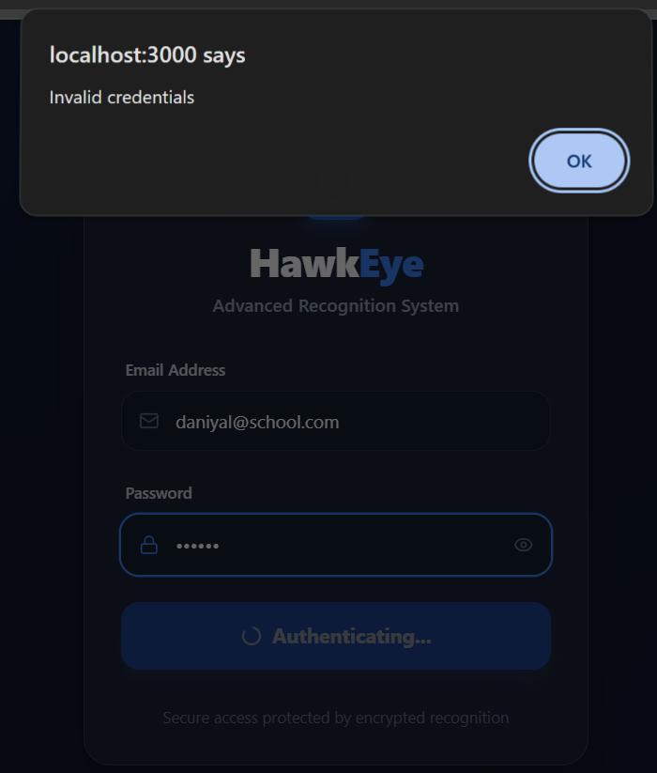  Incorrect | 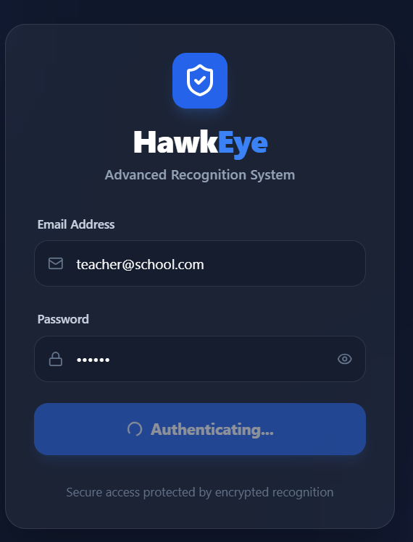  Correct

6.5.3 “Role-Based Access” Test Case
Field | Details
Test Case ID | TC-003
Use Case Name | Role-Based Access
Summary Description | Verify that different roles have restricted access to modules
Pre-Condition | Users must be registered with assigned roles (Admin, Discipline Incharge)
Test Procedure | 1. Login as Admin 2. Login as Discipline Incharge
Test Data | 1. Admin credentials 2. Discipline Incharge credentials
Expected Result | 1) Admin sees all modules 2) Discipline Incharge sees only allowed modules
Actual Result | 1) Admin access verified 2) Restricted access verified
Status | Pass

6.5.4 “Dashboard Load” Test Case
Field | Details
Test Case ID | TC-004
Use Case Name | Dashboard Load
Summary Description | Verify dashboard loads after successful login
Pre-Condition | User must be logged in
Test Procedure | 1. Login to system 2. Open dashboard
Test Data | Valid user credentials
Expected Result | 1) Dashboard loads successfully without errors
Actual Result | 1) Dashboard loaded successfully
Status | Pass

6.5.5 “Dashboard Data Display” Test Case
Field | Details
Test Case ID | TC-005
Use Case Name | Dashboard Data Display
Summary Description | Verify that dashboard statistics are displayed correctly
Pre-Condition | Dashboard must be loaded
Test Procedure | 1. Open dashboard 2. View statistics
Test Data | System-generated data
Expected Result | 1) All statistics are displayed correctly and accurately
Actual Result | 1) Data displayed correctly
Status | Pass

Screenshots:

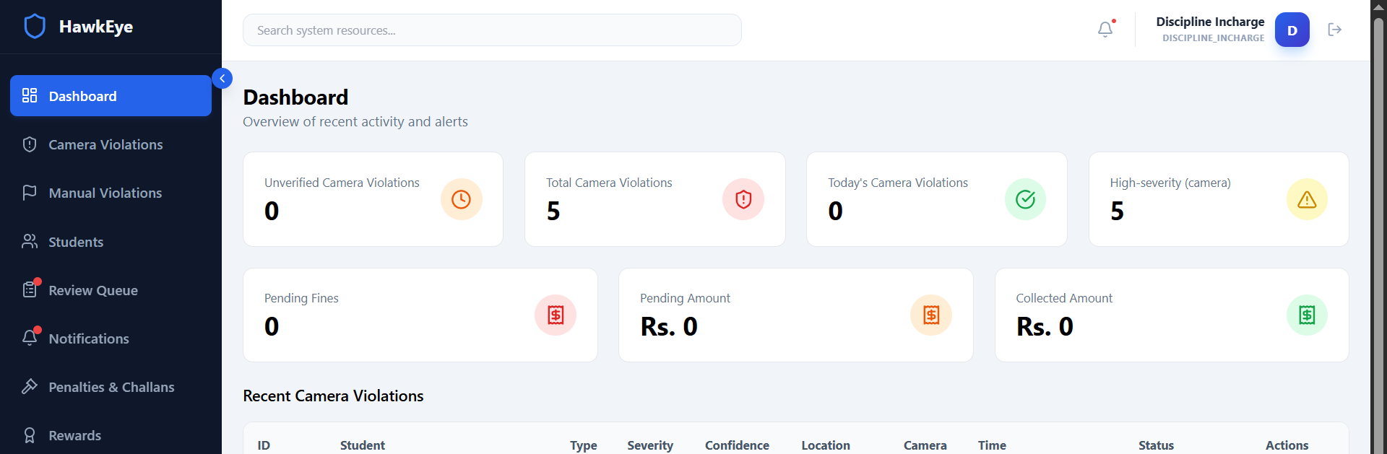

Discipline Incharge

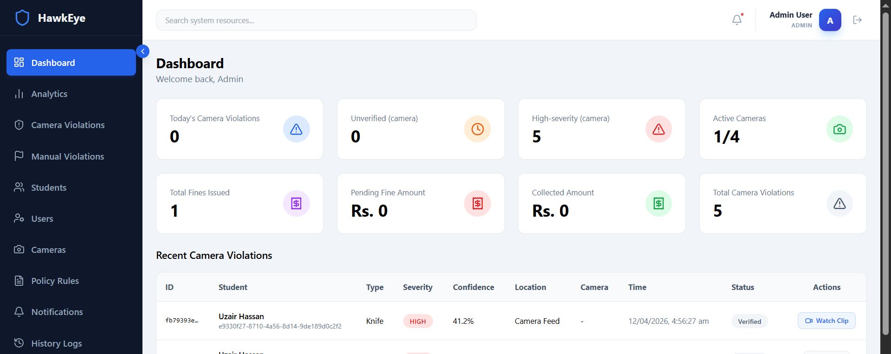

Admin

ADMIN TEST CASES

6.5.6 “Register Student (Camera)” Test Case
Field | Details
Test Case ID | TC-006
Use Case Name | Register Student (Camera)
Summary Description | Admin registers a student using live camera recording
Pre-Condition | Admin must be logged in Camera access should be enabled
Test Procedure | 1. Open student enrollment module 2. Record 10-second video 3. Fill student details form 4. Click “Submit” button
Test Data | 1. Enter Normal data • Name: “Ali Khan” • Video: Recorded (10 sec) 2. Enter Abnormal data • Name: “ ” • Video: Not recorded
Expected Result | 1) Show success message a. Student registered successfully b. Facial data stored 2) Show error message (“Please complete required fields”)
Actual Result | 1) Student registered successfully 2) Error message displayed
Status | Pass

6.5.7 “Register Student (Upload Video)” Test Case
Field | Details
Test Case ID | TC-007
Use Case Name | Register Student (Upload Video)
Summary Description | Admin registers a student by uploading a video
Pre-Condition | Admin must be logged in Video file must be available
Test Procedure | 1. Open student enrollment module 2. Upload video file 3. Fill student details form 4. Click “Submit” button
Test Data | 1. Enter Normal data • Name: “Ali Khan” • Video: Uploaded file 2. Enter Abnormal data • Name: “ ” • Video: Not uploaded
Expected Result | 1) Show success message (“Student registered successfully”) 2) Show error message (“Please complete required fields”)
Actual Result | 1) Student registered successfully 2) Error message displayed
Status | Pass

6.5.8 “Registration Validation” Test Case
Field | Details
Test Case ID | TC-008
Use Case Name | Registration Validation
Summary Description | Validate form submission with missing or empty fields
Pre-Condition | Admin must be on student registration page
Test Procedure | 1. Leave all required fields empty 2. Click “Submit” button
Test Data | 1. Enter Extreme data • Name: “ ” • Video: “ ” • Other fields: Empty
Expected Result | 1) Show validation error messages for required fields
Actual Result | 1) Validation errors displayed correctly
Status | Pass

Screenshots:

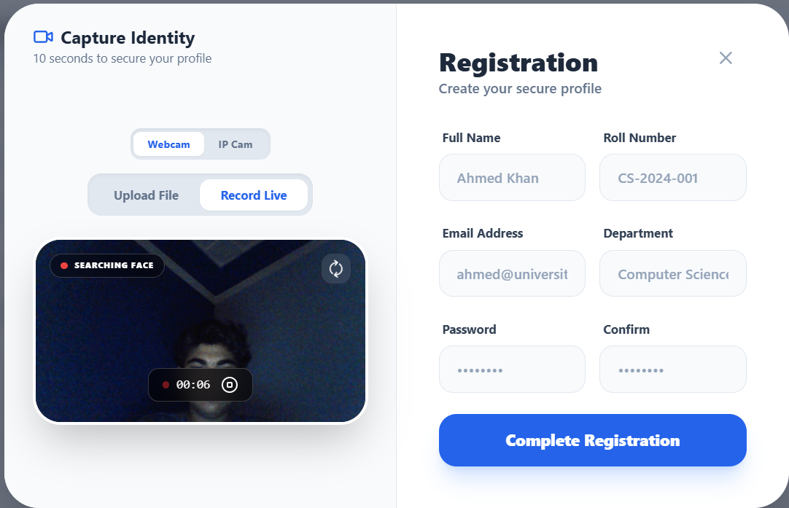

6.5.9 “View Students” Test Case
Field | Details
Test Case ID | TC-009
Use Case Name | View Students
Summary Description | Admin views the list of registered students
Pre-Condition | Admin must be logged in
Test Procedure | 1. Navigate to Student Management module 2. Click on “Students” page
Test Data | Existing student records in system
Expected Result | 1) List of all registered students is displayed
Actual Result | 1) Student list displayed successfully
Status | Pass

6.5.10 “Edit Student” Test Case
Field | Details
Test Case ID | TC-010
Use Case Name | Edit Student
Summary Description | Admin updates student information
Pre-Condition | Admin must be logged in Student record must exist
Test Procedure | 1. Open Student Management module 2. Select a student 3. Update details 4. Click “Save”
Test Data | 1. Enter Normal data • Name: “Ali Khan Updated” 2. Enter Abnormal data • Name: “ ”
Expected Result | 1) Changes saved successfully 2) Show validation error for invalid input
Actual Result | 1) Changes updated successfully 2) Error message displayed
Status | Pass

6.5.11 “Delete Student” Test Case
Field | Details
Test Case ID | TC-011
Use Case Name | Delete Student
Summary Description | Admin deletes a student record
Pre-Condition | Admin must be logged in Student record must exist
Test Procedure | 1. Open Student Management module 2. Select a student 3. Click “Delete” 4. Confirm deletion
Test Data | Existing student record
Expected Result | 1) Student is removed from system
Actual Result | 1) Student deleted successfully
Status | Pass

Screenshots
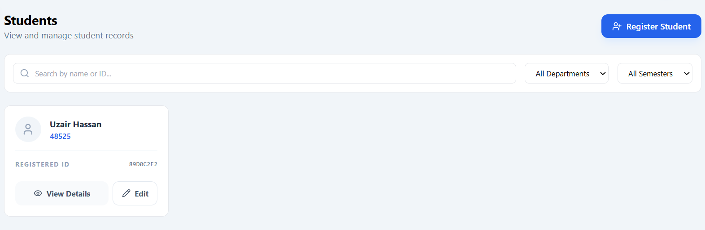

6.5.12 “Add Users” Test Case
Field | Details
Test Case ID | TC-012
Use Case Name | Add Users
Summary Description | Admin adds new users to the system
Pre-Condition | Admin must be logged in
Test Procedure | 1. Open User Management module 2. Click on “Add User” 3. Enter user details 4. Click “Submit”
Test Data | 1. Enter Normal data • Name: “Ahmed Ali” • Role: “Discipline Incharge” 2. Enter Abnormal data • Name: “ ”
Expected Result | 1) User added successfully 2) Show validation error for invalid input
Actual Result | 1) User added successfully 2) Error message displayed
Status | Pass

6.5.13 “Edit User” Test Case
Field | Details
Test Case ID | TC-013
Use Case Name | Edit User
Summary Description | Admin updates existing user information
Pre-Condition | Admin must be logged in User must exist
Test Procedure | 1. Open User Management module 2. Select a user 3. Modify details 4. Click “Save”
Test Data | 1. Enter Normal data • Name: “Ahmed Ali Updated” 2. Enter Abnormal data • Name: “ ”
Expected Result | 1) Changes updated successfully 2) Show validation error for invalid input
Actual Result | 1) Changes updated successfully 2) Error message displayed
Status | Pass

6.5.14 “Delete User” Test Case
Field | Details
Test Case ID | TC-014
Use Case Name | Delete User
Summary Description | Admin deletes an existing user
Pre-Condition | Admin must be logged in User must exist
Test Procedure | 1. Open User Management module 2. Select a user 3. Click “Delete” 4. Confirm deletion
Test Data | Existing user record
Expected Result | 1) User is removed from system
Actual Result | 1) User deleted successfully
Status | Pass

Screenshots:
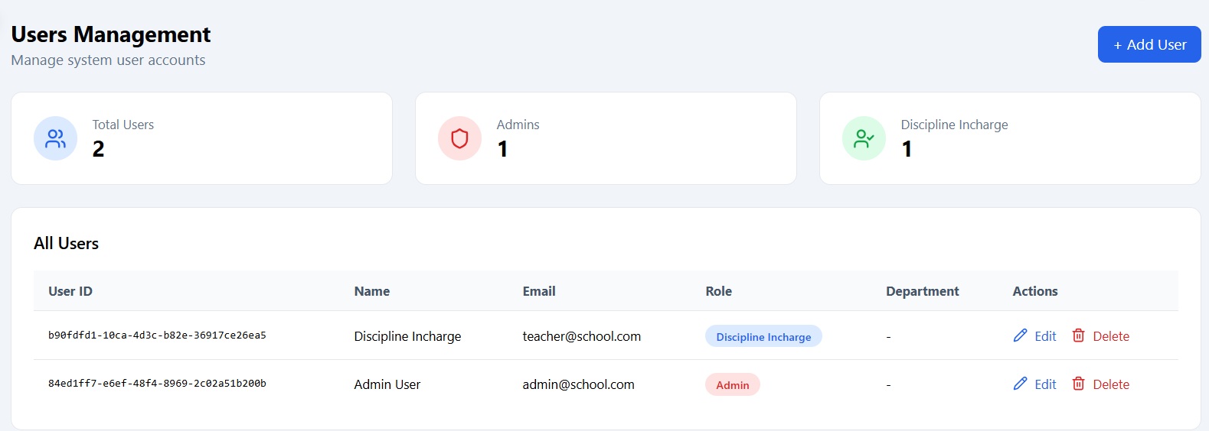

6.5.15 “Add Camera” Test Case
Field | Details
Test Case ID | TC-015
Use Case Name | Add Camera
Summary Description | Admin adds a new IP camera to the system
Pre-Condition | Admin must be logged in
Test Procedure | 1. Open Camera Management module 2. Click on “Add Camera” 3. Enter IP camera details 4. Click “Submit”
Test Data | 1. Enter Normal data • IP Address: “192.168.1.10” 2. Enter Abnormal data • IP Address: “999.999.999.999”
Expected Result | 1) Camera added successfully 2) Show error message (“Invalid IP address”)
Actual Result | 1) Camera added successfully 2) Error message displayed
Status | Pass

6.5.16 “Toggle AI Camera” Test Case
Field | Details
Test Case ID | TC-016
Use Case Name | Toggle AI Camera
Summary Description | Admin enables or disables AI functionality for a camera
Pre-Condition | Admin must be logged in Camera must exist
Test Procedure | 1. Open Camera Management module 2. Select a camera 3. Enable/disable AI toggle
Test Data | Existing camera record
Expected Result | 1) Camera AI status updates correctly
Actual Result | 1) Status updated successfully
Status | Pass

Screenshots:

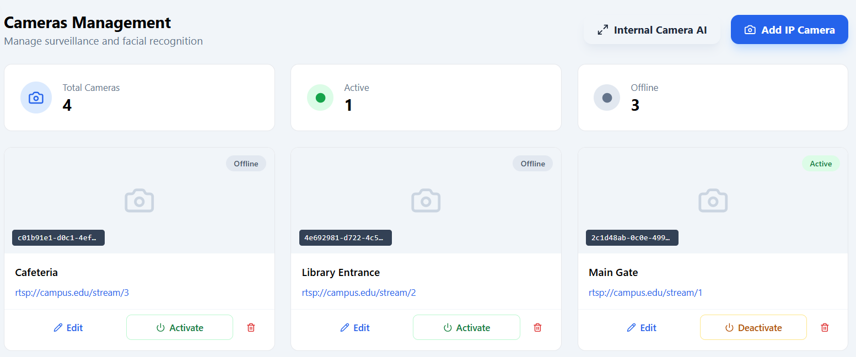

6.5.17 “Manage Policy” Test Case
Field | Details
Test Case ID | TC-017
Use Case Name | Manage Policy
Summary Description | Admin adds or edits policy rules in the system
Pre-Condition | Admin must be logged in
Test Procedure | 1. Open Policy Rules module 2. Click on “Add” or “Edit” rule 3. Enter or modify rule details 4. Click “Save”
Test Data | 1. Enter Normal data • Rule: “No mobile usage in class” 2. Enter Abnormal data • Rule: “ ”
Expected Result | 1) Rule saved successfully 2) Show validation error for empty input
Actual Result | 1) Rule saved successfully 2) Error message displayed
Status | Pass

6.5.18 “Delete Policy” Test Case
Field | Details
Test Case ID | TC-018
Use Case Name | Delete Policy
Summary Description | Admin deletes an existing policy rule
Pre-Condition | Admin must be logged in Policy rule must exist
Test Procedure | 1. Open Policy Rules module 2. Select a rule 3. Click “Delete” 4. Confirm deletion
Test Data | Existing policy rule
Expected Result | 1) Rule removed from system
Actual Result | 1) Rule deleted successfully
Status | Pass

Screenshots:
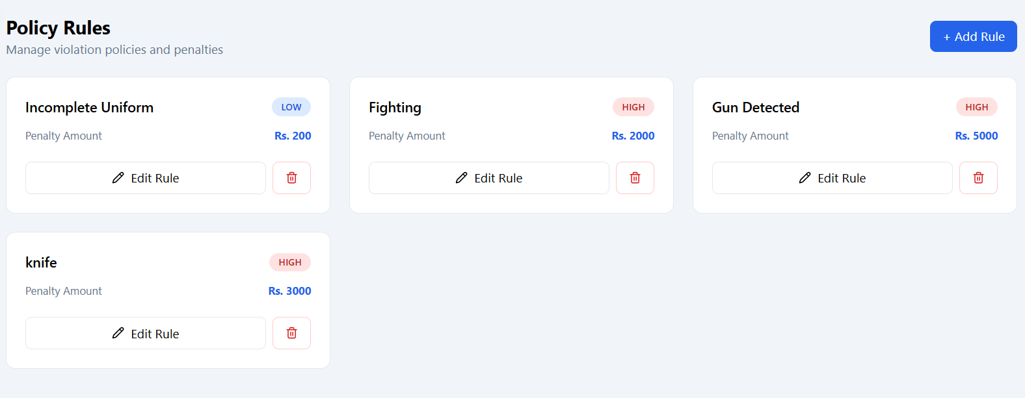

6.5.19 “View Notifications” Test Case
Field | Details
Test Case ID | TC-019
Use Case Name | View Notifications
Summary Description | User views system notifications
Pre-Condition | User must be logged in
Test Procedure | 1. Open Notifications module 2. Click on “Notifications”
Test Data | System-generated notifications
Expected Result | 1) Notifications are displayed correctly
Actual Result | 1) Notifications displayed successfully
Status | Pass

Screenshots:
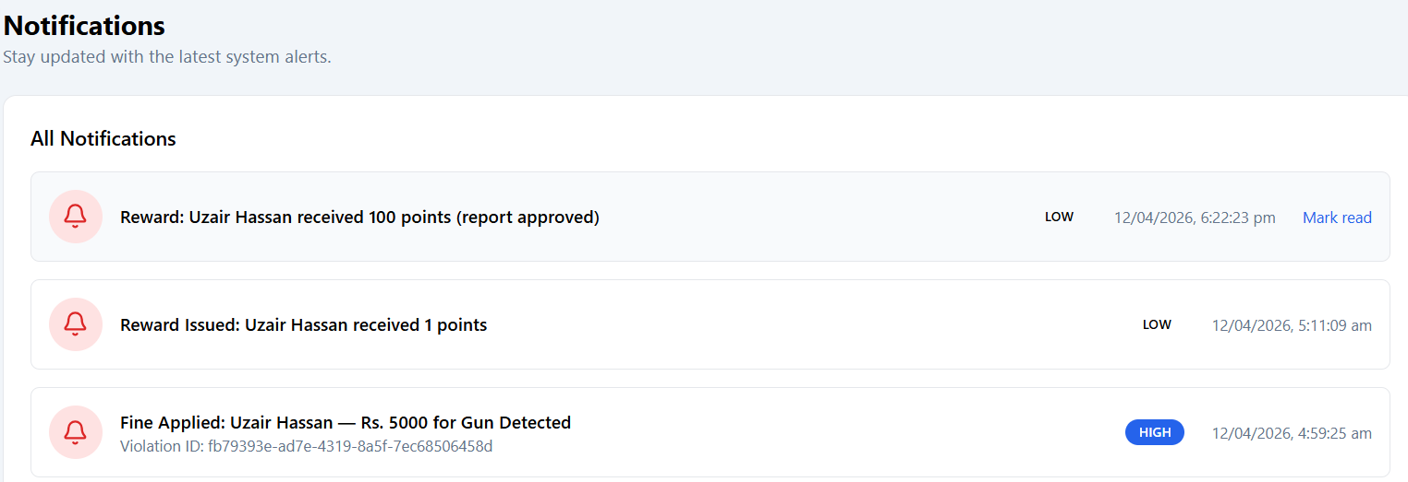

6.5.20 “View Logs” Test Case
Field | Details
Test Case ID | TC-020
Use Case Name | View Logs
Summary Description | User views system activity logs
Pre-Condition | User must be logged in
Test Procedure | 1. Open Logs module 2. Click on “History Logs”
Test Data | System activity records
Expected Result | 1) System activity is displayed correctly
Actual Result | 1) Logs displayed successfully
Status | Pass

Screenshots:
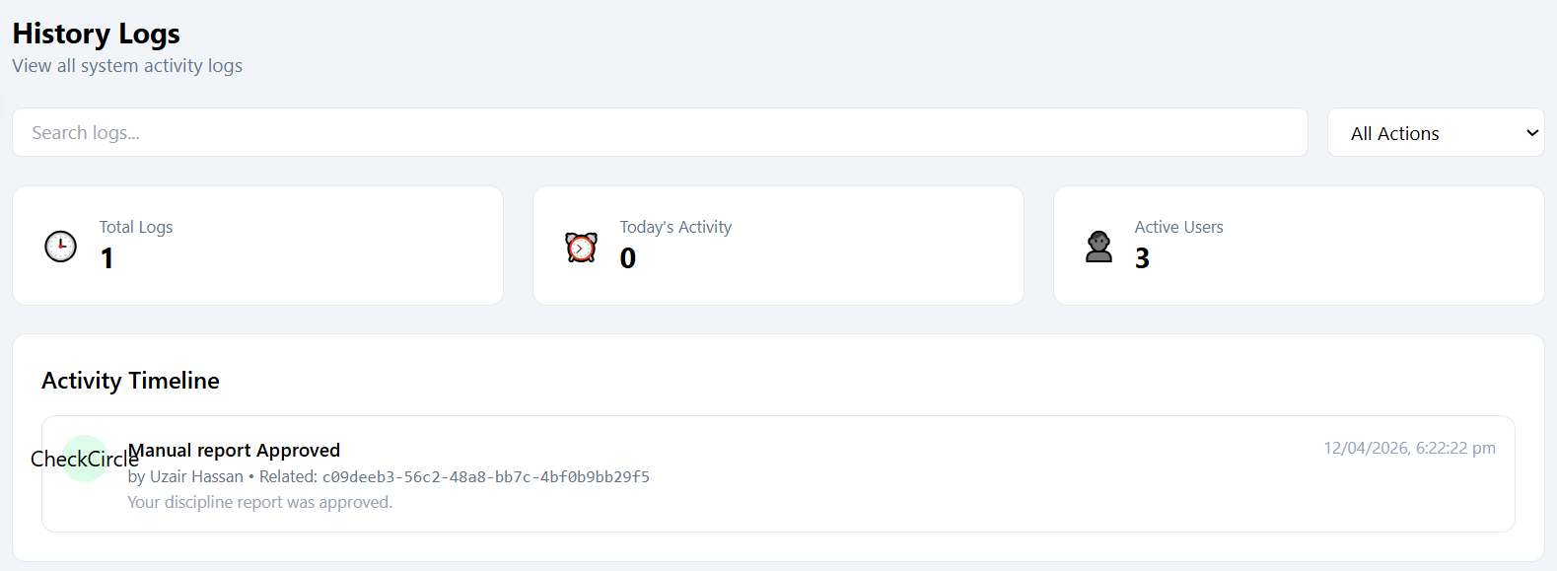

DISCIPLINE INCHARGE TEST CASES

6.5.21 “Dashboard Load” Test Case
Field | Details
Test Case ID | TC-021
Use Case Name | Dashboard Load
Summary Description | User logs in and accesses dashboard
Pre-Condition | User must be logged in
Test Procedure | 1. Login to system 2. Open dashboard
Test Data | Valid user credentials
Expected Result | 1) Dashboard loads correctly without errors
Actual Result | 1) Dashboard loaded successfully
Status | Pass

6.5.22 “Dashboard Data Accuracy” Test Case
Field | Details
Test Case ID | TC-022
Use Case Name | Dashboard Data Accuracy
Summary Description | Verify that dashboard statistics are accurate
Pre-Condition | Dashboard must be loaded
Test Procedure | 1. Open dashboard 2. View statistics section
Test Data | System-generated analytics data
Expected Result | 1) All displayed data is accurate and up-to-date
Actual Result | 1) Data displayed correctly
Status | Pass

Screenshots:

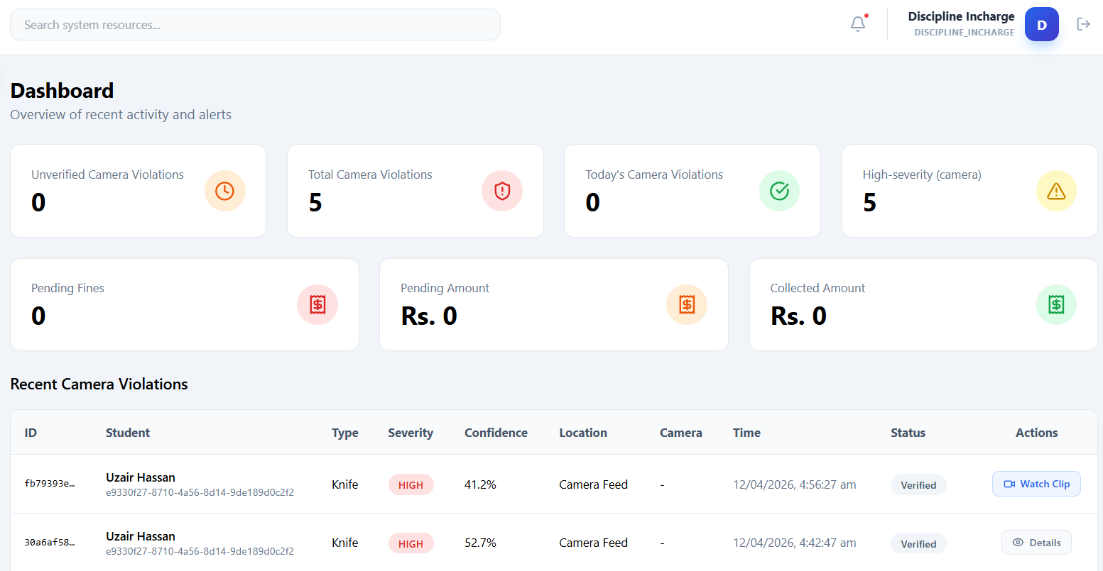

6.5.23 “View Students” Test Case
Field | Details
Test Case ID | TC-023
Use Case Name | View Students
Summary Description | User views the list of registered students
Pre-Condition | User must be logged in
Test Procedure | 1. Open Students module 2. Click on “Students List”
Test Data | Existing student records in system
Expected Result | 1) Student data is displayed correctly
Actual Result | 1) Student list displayed successfully
Status | Pass
Screenshots:

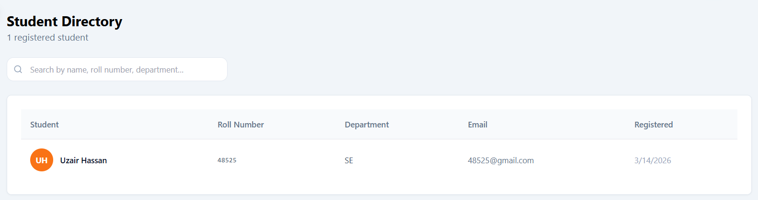

6.5.24 “View Review Queue” Test Case
Field | Details
Test Case ID | TC-024
Use Case Name | View Review Queue
Summary Description | User views all submitted violation evidences in review queue
Pre-Condition | User must be logged in as Discipline Incharge
Test Procedure | 1. Open Review Queue module
Test Data | Existing violation evidence records
Expected Result | 1) All evidences are listed correctly
Actual Result | 1) Review queue displayed successfully
Status | Pass

6.5.25 “Approve Violation” Test Case
Field | Details
Test Case ID | TC-025
Use Case Name | Approve Violation
Summary Description | Discipline Incharge approves a violation case
Pre-Condition | User must be logged in as Discipline Incharge Violation must exist in review queue
Test Procedure | 1. Open Review Queue 2. Select a violation 3. Click “Approve” button
Test Data | Existing violation record
Expected Result | 1) Status updated successfully 2) Fine is applied to student
Actual Result | 1) Status updated 2) Fine applied successfully
Status | Pass

6.5.26 “Dismiss Violation” Test Case
Field | Details
Test Case ID | TC-026
Use Case Name | Dismiss Violation
Summary Description | Discipline Incharge dismisses a reported violation
Pre-Condition | User must be logged in as Discipline Incharge Violation must exist
Test Procedure | 1. Open Review Queue 2. Select a violation 3. Click “Dismiss” button
Test Data | Existing violation record
Expected Result | 1) Violation status updated to dismissed
Actual Result | 1) Violation dismissed successfully
Status | Pass

Screenshots:
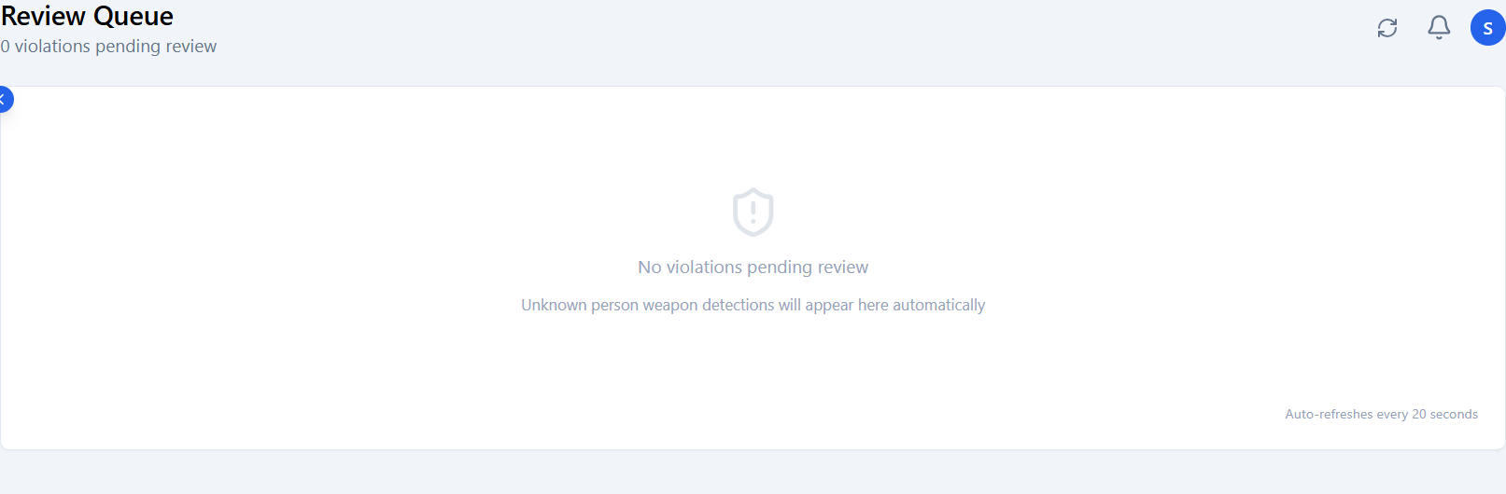

6.5.27 “View Camera Violations” Test Case
Field | Details
Test Case ID | TC-027
Use Case Name | View Camera Violations
Summary Description | User views all violations detected by camera system
Pre-Condition | User must be logged in as Discipline Incharge
Test Procedure | 1. Open Camera Violations module
Test Data | Existing camera-generated violation records
Expected Result | 1) All violations are displayed correctly
Actual Result | 1) Violations displayed successfully
Status | Pass

6.5.28 “Watch Clip” Test Case
Field | Details
Test Case ID | TC-028
Use Case Name | Watch Clip
Summary Description | User plays recorded video evidence of a violation
Pre-Condition | User must be logged in Violation video must exist
Test Procedure | 1. Open Camera Violations module 2. Select a violation 3. Click “Watch Clip”
Test Data | Existing video evidence
Expected Result | 1) Video plays successfully
Actual Result | 1) Video played without error
Status | Pass

Screenshots:

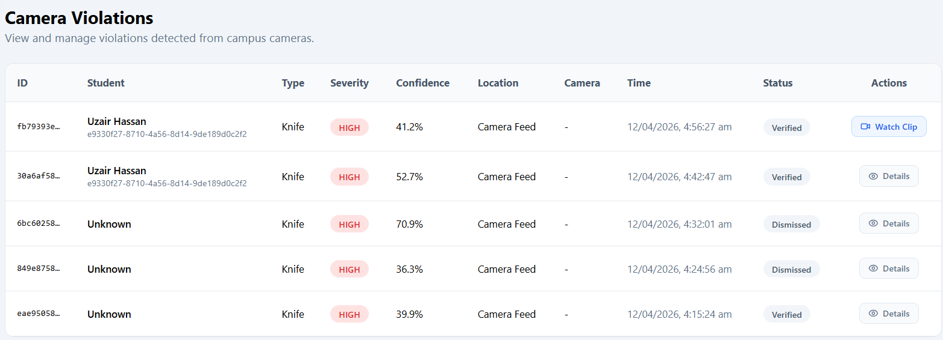

6.5.29 “Review Manual Violation” Test Case
Field | Details
Test Case ID | TC-029
Use Case Name | Review Manual Violation
Summary Description | User reviews manually submitted violation evidence
Pre-Condition | User must be logged in as Discipline Incharge
Test Procedure | 1. Open Manual Violations module 2. Open submitted evidence
Test Data | Existing manual violation records
Expected Result | 1) Evidence loads successfully
Actual Result | 1) Evidence displayed correctly
Status | Pass

6.5.30 “Fine + Reward Logic” Test Case
Field | Details
Test Case ID | TC-030
Use Case Name | Fine + Reward Logic
Summary Description | System applies fine and reward based on approved submission
Pre-Condition | User must be logged in as Discipline Incharge Submission must exist
Test Procedure | 1. Open Manual Violations module 2. Select submission 3. Click “Approve”
Test Data | Existing submitted violation evidence
Expected Result | 1) Fine applied to student 2) Reward issued successfully
Actual Result | 1) Fine applied 2) Reward issued
Status | Pass

Screenshots:

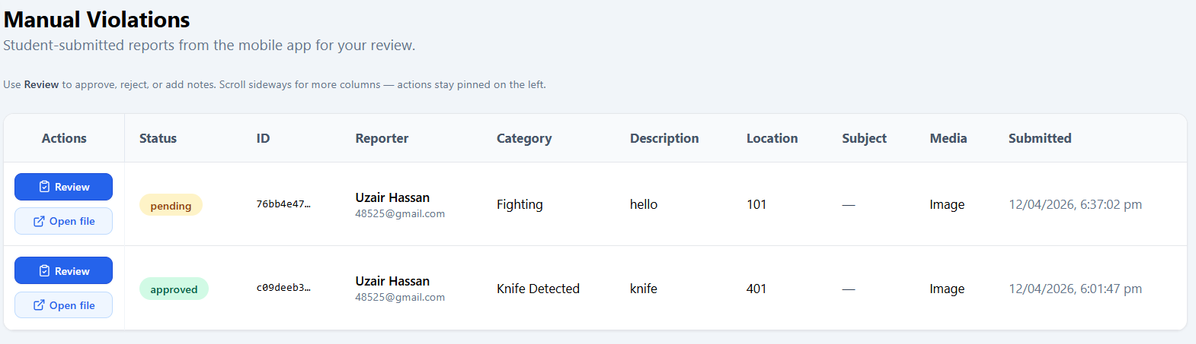

6.5.31 “View Notifications” Test Case
Field | Details
Test Case ID | TC-031
Use Case Name | View Notifications
Summary Description | User views system notifications
Pre-Condition | User must be logged in
Test Procedure | 1. Open Notifications module 2. Click on “Notifications”
Test Data | System-generated notification records
Expected Result | 1) Notifications are displayed correctly
Actual Result | 1) Notifications displayed successfully
Status | Pass

Screenshots:
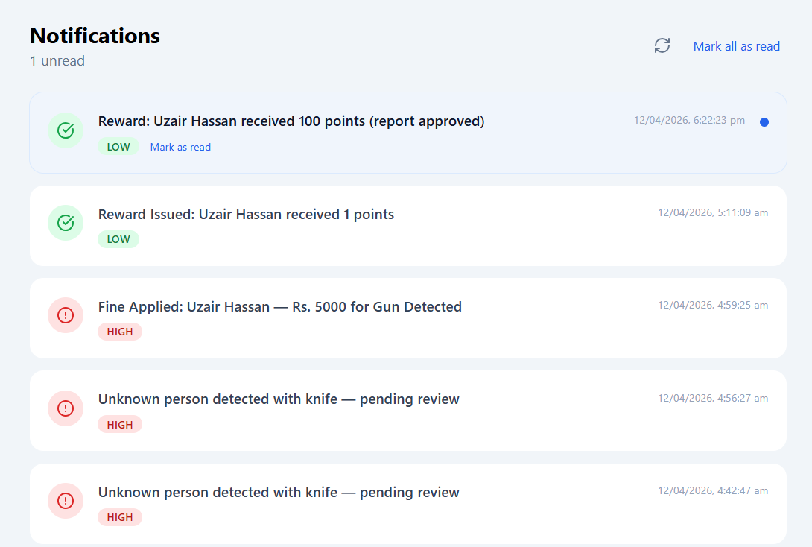

6.5.32 “Issue Reward” Test Case
Field | Details
Test Case ID | TC-032
Use Case Name | Issue Reward
Summary Description | Admin assigns reward points to a student
Pre-Condition | User must be logged in as Admin Student record must exist
Test Procedure | 1. Open Rewards module 2. Select student 3. Assign reward points
Test Data | Student ID and reward points
Expected Result | 1) Reward added successfully
Actual Result | 1) Reward assigned successfully
Status | Pass

6.5.33 “Reward Validation” Test Case
Field | Details
Test Case ID | TC-033
Use Case Name | Reward Validation
Summary Description | Validate reward form for empty submission
Pre-Condition | User must be logged in
Test Procedure | 1. Open Rewards module 2. Submit empty reward form
Test Data | Empty input fields
Expected Result | 1) Error message displayed
Actual Result | 1) Validation error shown
Status | Pass

6.5.34 “Reward Leaderboard” Test Case
Field | Details
Test Case ID | TC-034
Use Case Name | Reward Leaderboard
Summary Description | User views student ranking based on rewards
Pre-Condition | Rewards data must exist
Test Procedure | 1. Open Rewards module 2. Click on Leaderboard
Test Data | Existing reward points data
Expected Result | 1) Rankings are displayed correctly
Actual Result | 1) Leaderboard displayed successfully
Status | Pass

6.5.35 “Recent Rewards” Test Case
Field | Details
Test Case ID | TC-035
Use Case Name | Recent Rewards
Summary Description | User views recently issued rewards
Pre-Condition | User must be logged in Reward records must exist
Test Procedure | 1. Open Rewards module 2. Click on Rewards List
Test Data | Existing reward records
Expected Result | 1) Recent rewards are displayed correctly
Actual Result | 1) Rewards list displayed successfully
Status | Pass

Screenshots:
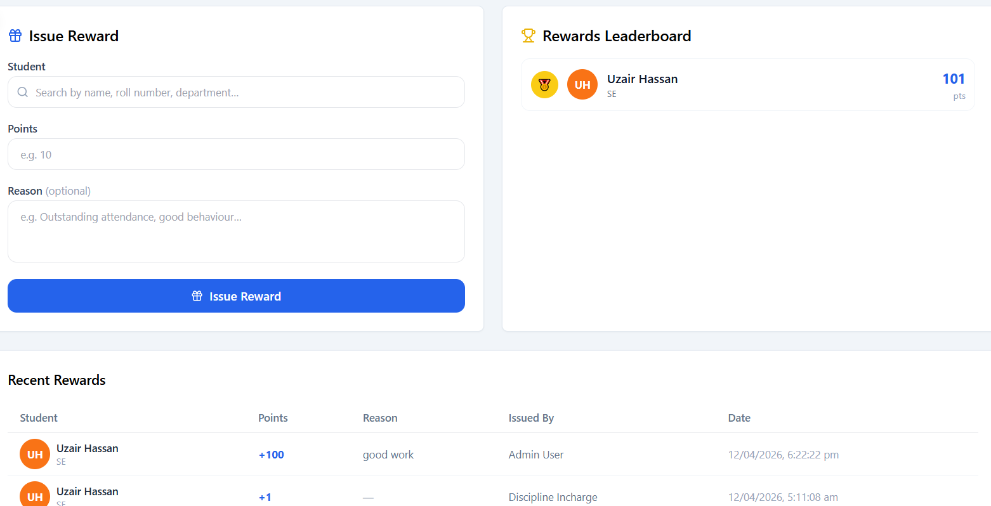

6.5.36 “View Fines” Test Case
Field | Details
Test Case ID | TC-036
Use Case Name | View Fines
Summary Description | User views all penalty fines assigned to students
Pre-Condition | User must be logged in
Test Procedure | 1. Open Penalties module 2. Click on Fines page
Test Data | Existing fine records
Expected Result | 1) Fines list is displayed correctly
Actual Result | 1) Fines displayed successfully
Status | Pass

6.5.37 “Update Fine Status” Test Case
Field | Details
Test Case ID | TC-037
Use Case Name | Update Fine Status
Summary Description | User updates status of a fine (paid/unpaid/cleared)
Pre-Condition | User must be logged in Fine record must exist
Test Procedure | 1. Open Penalties module 2. Select a fine 3. Change status
Test Data | Existing fine record
Expected Result | 1) Fine status updated successfully
Actual Result | 1) Status updated correctly
Status | Pass

6.5.38 “Pending Amount” Test Case
Field | Details
Test Case ID | TC-038
Use Case Name | Pending Amount
Summary Description | System calculates total pending fine amount
Pre-Condition | User must be logged in Fine records must exist
Test Procedure | 1. Open Penalties module 2. View pending amount section
Test Data | Existing unpaid fines
Expected Result | 1) Correct pending amount is calculated and displayed
Actual Result | 1) Amount displayed correctly
Status | Pass

6.5.39 “Unknown Person” Test Case
Field | Details
Test Case ID | TC-039
Use Case Name | Unknown Person
Summary Description | System identifies unknown person in camera violation
Pre-Condition | User must be logged in Camera detection active
Test Procedure | 1. Open Camera Violations module 2. View unknown detection entry
Test Data | Unrecognized face data
Expected Result | 1) Display “Unknown” for unidentified person
Actual Result | 1) Unknown label shown correctly
Status | Pass

6.5.40 “Mixed Evidence Handling” Test Case
Field | Details
Test Case ID | TC-040
Use Case Name | Mixed Evidence Handling
Summary Description | System processes multiple types of violation evidence correctly
Pre-Condition | User must be logged in as Discipline Incharge Multiple evidence types must exist
Test Procedure | 1. Open Review Queue 2. View multiple evidence entries
Test Data | Mixed evidence (video, manual, camera logs)
Expected Result | 1) All evidence types are handled and displayed correctly
Actual Result | 1) All handled successfully
Status | Pass

Screenshots:

